World Defence:

User Manual

Version 1.0

18/04/2015

Created By: Siobhan Wallace

Contact Me: Siobhan.wallace@student.glasgowclyde.ac.uk

Table of Contents

Introduction to World Defence 3

Copyright Note 3

Terminology 4

Game rules 4

Requirements and Installation 5

Minimum Requirements 5

The User Interface (UI) 5

Main Menu 5

Options Menu 6

Pause Screen 6

High Scores Screen 7

Game-Screen 7

Player Ships 8

Enemy Mobs 8

The Boss 8

Playing the Game 9

Control Scheme 9

Scoring 9

Being Defeated in the Game 9

Winning the Game 9

Restarting the Game 9

Quitting the Game 9

High Scores 10

Help! 10

# Introduction to World Defence

World Defence was conceptualised and created for submission as part of my HND Software Development: Year Two Graded Unit. In-depth research was conducted on the Fixed Shooter genre as a whole, with modern twists added in order to generate the game whilst avoiding being a direct “clone” of a game such as Space Invaders.

### Copyright Note

World Defence was created by and is the sole property of Siobhan Wallace.

Menu Music: ‘2ndBallad’ was created and is the sole property of ‘DST’ <http://www.nosoapradio.us/>

Game Music: ‘CryolithicBreak’ was created and is the sole property of ‘DST’ <http://www.nosoapradio.us/>

**The above assets can be used as they are licensed under the Creative Commons Attribution License.**

Enemy Laser: ‘sadpew’ was created for the sole purpose of being used in the game World Defence, and is intellectual property of its creator, Jamie Devlin.

Player Laser: ‘happypew’ was created for the sole purpose of being used in the game World Defence, and is intellectual property of its creator, Jamie Devlin

Explosion: ‘explosion’ was created for the sole purpose of being used in the game World Defence, and is intellectual property of its creator, Jamie Devlin.

All other in-game assets are owned by Siobhan Wallace

## Terminology

Certain terminology will be used throughout this manual that you may be unfamiliar with, which will be listed and explained here.

**Spawn** – The player is created at the start of the game (spawned), along with the enemies, which are created (spawned) at the start of every round.

**Waves** - A fixed-size group of enemies that appear and move together for the player to defeat.

**Co-Op** – Short for co-operative, Co-Op Mode allows two players to work together in order to defeat the enemies.

**Arcade** – The ‘old-school’ mode of the game, Arcade mode is the version of the game most like its inspirations, Space Invaders and Galaxia.

**Mob(s)** – Short for monster, this is a generic term with widespread use, and is used to refer to the enemies that the player faces.

**HP** – Shorthand for Hit Points, HP is how much health the player or enemies have left.

**Boss** - A general term used to describe an enemy of greater difficulty, the boss is usually signified as the end game fight. The player faces the boss in the final wave of Endless Mode, and the final wave of Co-Op Mode.

**Mini-Boss** – A tougher than average enemy, but still not as powerful as the actual boss mob. Mini-Bosses are encountered by the player in Endless-Mode every 11 waves.

## Game rules

As World Defence is a Fixed Shooter game, it has very few rules.

1. The player must defeat waves of mobs in order to advance to the next level
2. The player is defeated if they either fail to stop the mobs or are killed.

## Requirements and Installation

World Defence uses Microsoft’s ClickOnce deployment, and as a result, the installation is simple.

Double-click the game’s setup.exe and follow the onscreen instructions.

### Minimum Requirements

Operating System: Windows XP, SP2

Video Card: Support for Shader Model 1.1

**NOTE: In order for the high score database to function, either Microsoft Access or Microsoft Access Runtime must be installed.**

Microsoft Access Runtime can be found here: <http://www.microsoft.com/en-gb/download/details.aspx?id=39358>

## The User Interface (UI)

### Main Menu

This is the main menu of the game, where the player can select which game mode they would like to play, enter the high scores screen, change the options or quit the game.

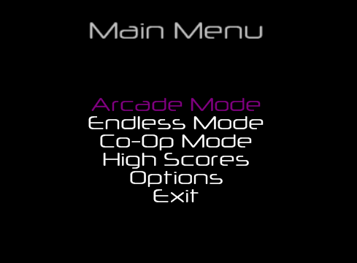

### Options Menu

This is the options menu, as seen in-game. Here the player can choose to toggle game music on/off, choose their ship design, change their laser colour or return to the main menu.

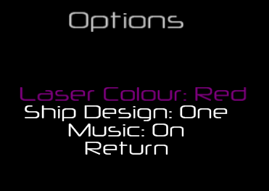

### Pause Screen

This is the pause screen, as seen in-game. Here the player can choose to resume their game or return to the main menu.

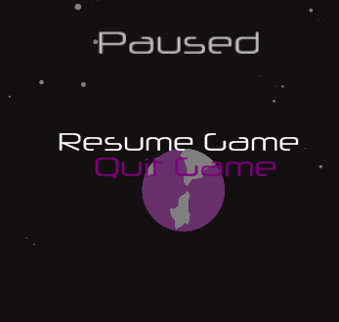

### High Scores Screen

This is the high score screen as seen in-game. Here the player can choose which game mode to view ranks for, and can return to the main menu.

### Game-Screen

This is the game screen seen when a game mode is first begun. The player can track their current score and lives left, can see the enemies to be defeated and can see their player ship. (In Co-Op Mode, player 2 starts to the right of player 1.)

### Player Ships

These are the 3 options available to the player for their ship.

C:\Users\Siobhan\Desktop\wat\Game Resources\finished mobs\transparent mobs\Player3.pngC:\Users\Siobhan\Desktop\wat\Game Resources\finished mobs\transparent mobs\Player2.pngC:\Users\Siobhan\Desktop\wat\Game Resources\finished mobs\transparent mobs\Player1.png

**This is your laser! It can be colour customised in the options menu.**

C:\Users\Siobhan\Desktop\wat\Game Resources\finished mobs\transparent lasers\Player Laser.png

### Enemy Mobs

These are the 4 kinds of mobs seen in game. They have no differences aside from looks, and points awarded.

C:\Users\Siobhan\Desktop\wat\Game Resources\finished mobs\transparent mobs\Mob4.pngC:\Users\Siobhan\Desktop\wat\Game Resources\finished mobs\transparent mobs\Mob3.pngC:\Users\Siobhan\Desktop\wat\Game Resources\finished mobs\transparent mobs\mob2.pngC:\Users\Siobhan\Desktop\wat\Game Resources\finished mobs\transparent mobs\mob1.png

**This is the enemy laser, watch out for it!**

**C:\Users\Siobhan\Desktop\wat\Game Resources\finished mobs\transparent lasers\Enemy Laser.png**

### The Boss

This is the boss of the game (boo!). His health increases in Endless Mode each time you fight him!



**This is the boss’ laser, how evil!**



# Playing the Game

In World Defence, the player can shoot lasers and move left or right in their quest to defeat the advancing waves of enemies.

## Control Scheme

World Defence can be played using an Xbox 360 controller or the keyboard. Mouse input is not currently supported.

**Left** – A or Left Arrow Key (Left-Joystick Left)

**Right** – D or Right Arrow Key (Left-Joystick Right)

**Shoot** – Spacebar or Numpad 0 (Button A)

**Pause** – Esc

## Scoring

|  |  |
| --- | --- |
| Enemy | Points Awarded |
| Line 1 Mob | 15 |
| Line 2 Mob | 25 |
| Line 3 Mob | 50 |
| Line 4 Mob | 75 |
| Boss | 100 |

## Being Defeated in the Game

If the player is hit 3 times by the mobs, or fails to stop the mobs from reaching the bottom of the game-screen, they are considered defeated and game over occurs. However, don’t feel down if this happens, you still get to add your name and score to the high score database!

## Winning the Game

If the players defeat the boss in Co-Op Mode, or defeat the final wave of mobs in Arcade Mode, they are said to have won the game, and will be prompted to enter their name into the high score database.

## Restarting the Game

The game can be paused or restarted at any point by pressing the pause button (Esc) and selecting end game, then choosing to restart the game mode. (Although your score won’t be saved!)

## Quitting the Game

The game can be quit at any point by pressing pause (Esc) and selecting exit game, or by pressing the X at the top of the screen.

## High Scores

The high Scores can be viewed by selecting the ‘High Score’s option from the Main Menu.

Upon defeat or victory, the player will be prompted to enter their name for the high score. Names entered by the player must contain no numeric values and be within the 15 character limit.

# Help!

**Game not running/working properly**

* Make sure the game has installed correctly, if necessary, re-run the setup.exe and select the repair option.
* Make sure to press “Yes” when prompted by User Access Control if you would like to allow the gamer to make changes to your computer (this is necessary for the high score database)

**Can’t view the high scores**

* Make sure to press “Yes” when prompted by User Access Control if you would like to allow the gamer to make changes to your computer (this is necessary for the high score database)

***Make sure you have Microsoft Access Runtime installed (link is available in the requirements section)***

**Error – Can’t find HighscoreDB.accdb / is corrupted**

* Ensure you haven’t accidentally deleted/modified/moved the database file
* If necessary, re-run the setup.exe and select the repair option.

**Error – File not found**

* Ensure you haven’t accidentally deleted/modified/moved the missing file
* If necessary, re-run the setup.exe and select the repair option.